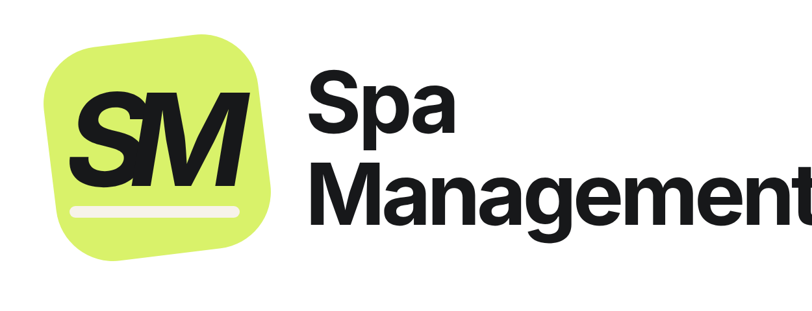  Powered by  | Spa Management  1997labs Tech Solutions  ask@spamanagement.co · 1997labs.com

Invoice
  Invoice no. | [SM-INV-2026-000]
  Date | [DD Mon YYYY]
  Balance due | [AED 0,000 on receipt]
  Currency | AED

BILL TO  [Spa legal name]  [Area, City], United Arab Emirates  Tel: [phone] · WhatsApp: [WhatsApp] |  | PLAN  [Premium] plan SPECIAL OFFER  [Spa name] gets every [Premium] feature at the [Standard] plan price, as a special offer from Spa Management.  Website: 2 languages, English + Arabic. CRM system: 2 languages, English + Thai.

Invoice details
Description | Qty | Unit price | Amount
[Premium] plan: setup (one time)  Website design in 2 languages (English + Arabic); CRM system in 2 languages (English + Thai); onboarding, data import, menu, rooms and team set-up | 1 | [14,000.00] | [14,000.00]
SPECIAL OFFER [Premium at the Standard price] | 1 | [−5,000.00] | [−5,000.00]
Total setup (AED) |  |  | [9,000.00]
Less: down payment received |  |  | [−0,000.00]
Balance due (AED) |  |  | [0,000.00]
You save AED [5,000] on setup compared with the [Premium] list price. The monthly subscription (AED [2,000] instead of AED [3,000]) is invoiced separately each month and is due by the 10th of the month.
Payment
- Payment by bank transfer, cash or card payment link.
- Down payment of AED [0,000] already received with thanks. The remaining balance of AED [0,000] is due on receipt of this invoice.
This is an official invoice issued by 1997labs Tech Solutions (Spa Management); no stamp or signature is needed.

[Premium] features included
Feature | Included
A. Website
Website in 2 languages: English + Arabic (Arabic right-to-left); professionally designed and fast on phones | ✓
Your own website address with free SSL certificate | ✓
Services and prices, team and opening hours shown live from the system (prices can be hidden) | ✓
Home, Services, About, Contact and other pages; map link, phones, WhatsApp buttons and social links | ✓
Online booking with live free times, 24/7 | ✓
Website enquiry and booking-request forms straight into the system (no email needed) | ✓
SEO basics: page titles and descriptions, sitemap, Google structured data, Search Console, redirects from old links | ✓
Google Ads / analytics tags and a moving offer bar | ✓
Website changes by our team ("Request a change" from your dashboard) | ✓
B. Bookings and calendar
Calendar by therapist and room; no double bookings | ✓
Walk-ins with a fair turn list, waitlist, confirm / check-in / finish flow | ✓
WhatsApp confirmations, reminders and thank-you messages (ready to send in one tap) | ✓
Dashboard: today's bookings and sales together, website alerts with pop-up and sound | ✓
C. Sales and point of sale
Sales and checkout; payments recorded by cash, card terminal or bank transfer; tips | ✓
Daily close and daily sales sheet (PDF) | ✓
Gift vouchers, packages and memberships | ✓
Products and stock, purchases, low-stock alerts | ✓
D. Clients
Client records with visit history, notes, UAE and international phone numbers | ✓
Intake and waiver forms (PDF), duplicate merge, import and export | ✓
E. Team and payroll
Staff profiles, roles and permissions, time clock | ✓
Commissions, payroll and WPS salary file | ✓
Staff documents with expiry reminders (visa, licence) | ✓
F. Finance and reports
Reports and KPIs, profit and loss, tax reports, expenses, accounting export | ✓
G. Marketing and growth
Google Business Profile link and reviews | ✓
H. Included with every plan
CRM system in 2 languages: English + Thai; installs as an app on phones and tablets | ✓
Two-step login, activity log, daily backups, secure hosting in the cloud | ✓
Updates and new features at no extra cost; support by WhatsApp and email | ✓

